Automated Installation of BI Dry 3.0
To run BI Dry 3.0, two software components must be installed:
- COMSOL Runtime (developed by COMSOL)
- BI Dry 3.0 (developed by Heidelberg Materials Betong and Deflexional)
It is possible to install both COMSOL Runtime and BI Dry using automated installation, but it needs to be done in two steps.

COMSOL Runtime Installation
First, you need to obtain the ISO-file (e.g., COMSOL63_runtime_dvd.iso) from Heidelberg Materials. Then follow these steps:
- Mount the DVD-iso file. In Windows, this can be done by right-clicking on the ISO-file and then selecting Mount.
Tip: If "Mount" doesn’t show up, make sure the ISO file is associated with Windows Explorer
- Open the mounted directory (e.g., D:) and copy the setupconfig.ini file to a local directory (e.g., C:/xxx_temp/setupconfig.ini)
- Open the copied setupconfig.ini in a text editor and add the installation directory:
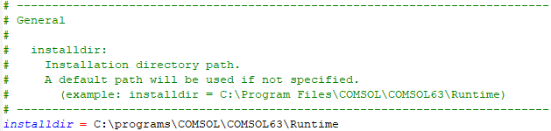
- Using administrative rights, open a command prompt and type in the following when using the example directories above:
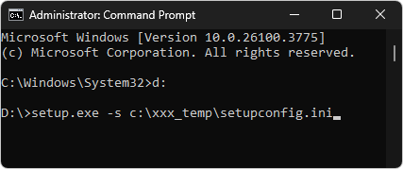
- The installation guide for COMSOL Multiphysics, which is applicable to COMSOL Runtime is available for download here: https://comsol.com/iog

BI Dry 3.0 Installation
An automated installation of BI Dry 3.0 is straightforward. Before you begin you need the installer (e.g., BI-Dry_3_0_0_23_installer.exe) which is available for download here:
https://www.betong.heidelbergmaterials.se/sv/bidry
The EXE-file can use these different flags for automated installation:
- /DIR=”x:\dirname”
- /SILENT – Silent mode. The progress window is displayed.
- /VERYSILENT - Very silent mode. No windows are displayed.
Below are examples of how to run the installer in different modes:
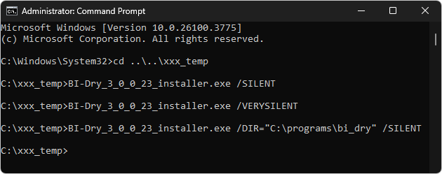
For a full list of available commands, see:
https://jrsoftware.org/ishelp/index.php?topic=setupcmdline

